Customer Purchase Behavior Dataset

Introduction :
Customer Purchase Behavior Analytics is a data visualization and analysis project designed to understand how customers interact with a business through their purchases, demographic characteristics, engagement level, and online behavior. Using a 500,000-record dataset, this project aims to uncover actionable insights that support marketing strategies, customer segmentation, business growth, and sales optimization.
Tableau is used to clean, prepare, analyze, and visualize the dataset. With interactive dashboards, stakeholders can track purchasing trends, understand customer satisfaction, evaluate product category performance, and examine behavior patterns across regions and segments.
The project provides a comprehensive analysis of how different factors—such as age, income, product preferences, time spent on the website, discounts availed, loyalty membership, and customer segments—shape overall purchase behavior.

Scenario 1: Marketing Strategy Optimization

In this Scenario, Marketing teams can use Tableau insights to find which customer segments purchase the most, which regions perform well, and which product categories need more promotion. By analyzing customer demographics and engagement metrics such as time spent on the website, referral sources, and discounts availed, marketers can design targeted campaigns. Insights help identify high-value customers, loyal segments, and customer groups that require retention strategies.

Scenario 2: Customer Experience & Satisfaction Analysis

In this Scenario,Customer satisfaction scores, session counts, tenure, and purchase history allow companies to study how customer experience influences purchases. Tableau dashboards highlight patterns in satisfaction across customer segments like VIP, Premium, and Regular customers. Businesses can detect areas where customer experience is declining and address issues through improved service quality, personalized offers, and loyalty initiatives.

Scenario 3: Product & Revenue Optimization

Sales and product teams can use visualizations to understand top-performing product categories, customer device preferences, and repeat-purchase behavior. Tableau insights allow comparison of Electronics, Furniture, and other product lines, helping identify high-demand categories. Real-time views of purchase status and frequency help optimize inventory, pricing strategy, and product forecasting.

Technical Architecture:

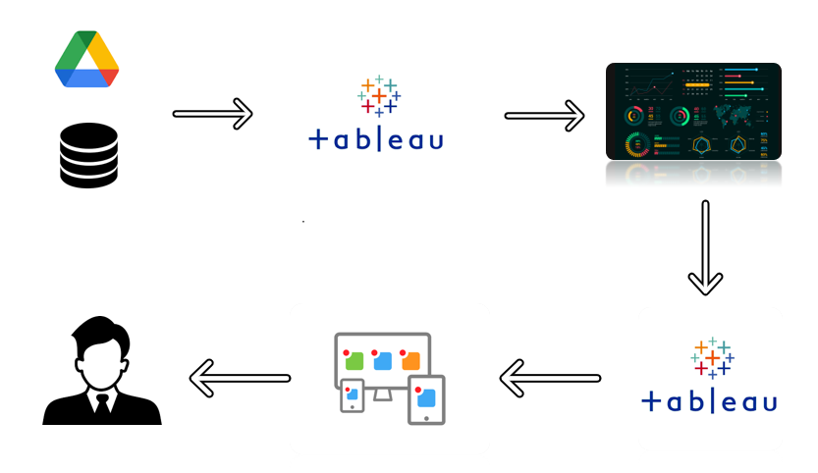

Project Flow
To accomplish this, we have to complete all the activities listed below,
- Define Problem / Problem Understanding
  - Specify the business problem
  - Business requirements
  - Literature Survey
  - Social or Business Impact.
- Data Collection & Extraction from Database
  - Collect the dataset,
  - Storing Data in DB
  - Perform SQL Operations
  - Connect DB with Tableau
- Data Preparation
  - Prepare the Data for Visualization
- Data Visualizations
  - No of Unique Visualizations
- Dashboard
  - Responsive and Design of Dashboard
- Story
  - No of Scenes of Story
- Performance Testing
  - Amount of Data Rendered to DB ‘
  - Utilization of Data Filters
  - No of Calculation Fields
  - No of Visualizations/ Graphs
- Web Integration
  - Dashboard and Story embed with UI With Flask
- Project Demonstration & Documentation
  - Record explanation Video for project end to end solution
  - Project Documentation-Step by step project development procedure

Milestone 1: Data Collection & Extraction from Database

Data collection is the process of gathering and measuring information on variables of interest, in an established systematic fashion that enables one to answer stated research questions, test hypotheses, and evaluate outcomes and generate insights from the data.

Activity 1: Collect the dataset

Please use the link to download the dataset: https://www.kaggle.com/datasets/gauthamvijayaraj/customer-purchase-behavior-dataset-e-commerce

Activity 1.1: Understand the data

Data contains all the meta information regarding the columns described in the CSV files. we have provided 1 CSV file:
1. CustomersData.csv
Column Description of the Dataset
- Age
- Age_Group
- Age (bin)
- Customer Segment
- Gender
- Number of Purchase
- Preferred device
- Product Category
- Region
- Session Count(bin)
- Annual Income
- Customer Satisfaction
- Customer Tenure Years
- Discount Availed
- Index
- Number of Customers
- Number of Purchase
- Purchase Status
- Time Spend on Website in Hours
- Customer Data Source

Activity 2: Storing Data in DB & Perform SQL Operations
Explanation video link:
Storing Data into.mp4
Activity 3: Connect DB with Tableau
Explanation video link:
Connecting to DB.mp4

Milestone 2: Data Preparation

Activity 1: Prepare the Data for Visualization

Preparing the data for visualization involves cleaning the data to remove irrelevant or missing data, transforming the data into a format that can be easily visualized, exploring the data to identify patterns and trends, filtering the data to focus on specific subsets of data, preparing the data for visualization software, and ensuring the data is accurate and complete. This process helps to make the data easily understandable and ready for creating visualizations to gain insights into the performance and efficiency.

Milestone 3: Data Visualization

Data visualization is the process of creating graphical representations of data in order to help people understand and explore the information. The goal of data visualization is to make complex data sets more accessible, intuitive, and easier to interpret. By using visual elements such as charts, graphs, and maps, data visualizations can help people quickly identify patterns, trends, and outliers in the data.

Activity 1: No of Unique Visualizations

In the Customer Purchase Behavior Dataset, we can created many unique visualizations in Tableau to understand customer activity and buying patterns. Common visuals include bar charts, line charts, scatter plots, heatmaps, donut charts, and maps. These charts help us compare purchases and sessions across different regions, track how customer engagement changes over time, and understand the distribution of customer behavior. They also reveal relationships between key factors like session count and the number of purchases, and allow us to see how different customer segments contribute to overall performance. Overall, these visualizations provide clear insights into customer behavior and help in making better business decisions.

Activity 1.1: Total Customers

Explanation video link: Total Customers.mp4
Activity 1.2: Average Annual Income
Explanation video link: Average Annual Income.mp4

Activity 1.3: Total Purchase
Explanation video link: Total Purchase.mp4

Activity 1.4: Average Customer Satisfaction
Explanation video link: Average Customer Satisfaction.mp4
Activity 1.5: Age Group Distribution
Explanation video link:Age Group Distribution.mp4

Activity 1.6: Gender Distribution
Explanation video link:Gender Distribution.mp4

Activity 1.7: Trend by Age Group
Explanation video link:
Trend by Age Group.mp4
Activity 1.8: Region- wise Purchase
Explanation video link: Region wise Purchase.mp4

Activity 1.9: Number of Purchase Per Product Category
Explanation video link:Number of Purchase per product category.mp4

Activity 1.10: Number of Purchase by Age Group
Explanation video link: Number of purchase by age group.mp4

Activity 1.11: Distribution of Purchase by Age
Explanation video link: Distribution of Purchase by age.mp4

Activity 1.12: Discounts Availed vs Number of Purchase
Explanation video link: Discounts Availed vs Number of Purchase.mp4

Milestone 4: Dashboard
A dashboard is a graphical user interface (GUI) that displays information and data in an organized, easy-to-read format. Dashboards are often used to provide real-time monitoring and analysis of data, and are typically designed for a specific purpose or use case. Dashboards can be used in a variety of settings, such as business, finance, manufacturing, healthcare, and many other industries. They can be used to track key performance indicators (KPIs), monitor performance metrics, and display data in the form of charts, graphs, and tables.
Activity :1- Responsive and Design of Dashboard
The responsiveness and design of the Customer Purchase Behavior Dashboard play an important role in making the insights easy to understand and use. A well-designed dashboard ensures that users can quickly interpret key metrics like purchases, sessions, and customer behavior patterns. Good design includes clear layout, clean formatting, readable KPIs, and consistent color usage. Responsiveness ensures the dashboard adjusts well on different screen sizes without losing clarity. Interactivity—such as filters, tooltips, and drill-downs—helps users explore the data in detail. Overall, the goal is to create a dashboard that is simple, user-friendly, visually appealing, and effective in delivering meaningful insights about customer behavior.
Once you have created views on different sheets in Tableau, you can pull them into a dashboard.
Explanation video link: Tableau dashboard.mp4
https://public.tableau.com/views/firstDashboard_17646695125330/Dashboard1?:language=en-US&:sid=&:redirect=auth&:display_count=n&:origin=viz_share_link.
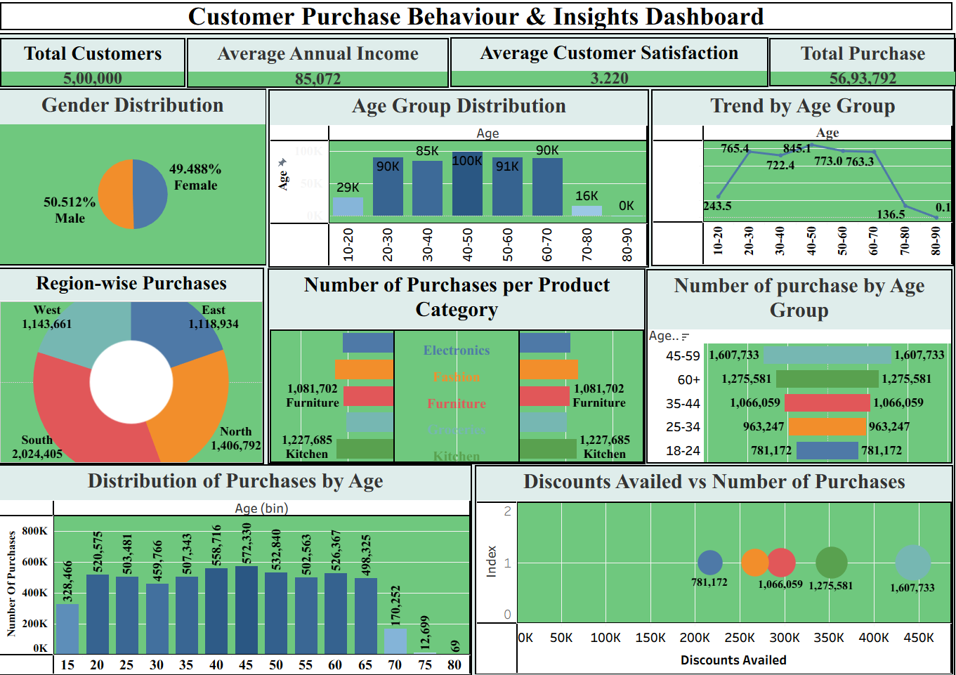
Milestone 5: Story
A data story is a way of presenting data and analysis in a narrative format, with the goal of making the information more engaging and easier to understand. A data story typically includes a clear introduction that sets the stage and explains the context for the data, a body that presents the data and analysis in a logical and systematic way, and a conclusion that summarizes the key findings and highlights their implications. Data stories can be told using a variety of mediums, such as reports, presentations, interactive visualizations, and videos.
Activity:1- No of Scenes of Story
The number of scenes in a storyboard for a data visualization analysis of the performance ChronoConflict Tableau Insights into Five Decades of Global Terrorist Activities Will depend on the complexity of the analysis and the specific insights that are trying to be conveyed. A storyboard is a visual representation of the data analysis process and it breaks down the analysis into a series of steps or scenes.
Explanation video link:
Story telling.mp4
https://public.tableau.com/views/firstStory_17646696595630/Story1?:language=en-US&publish=yes&:sid=&:redirect=auth&:display_count=n&:origin=viz_share_link .
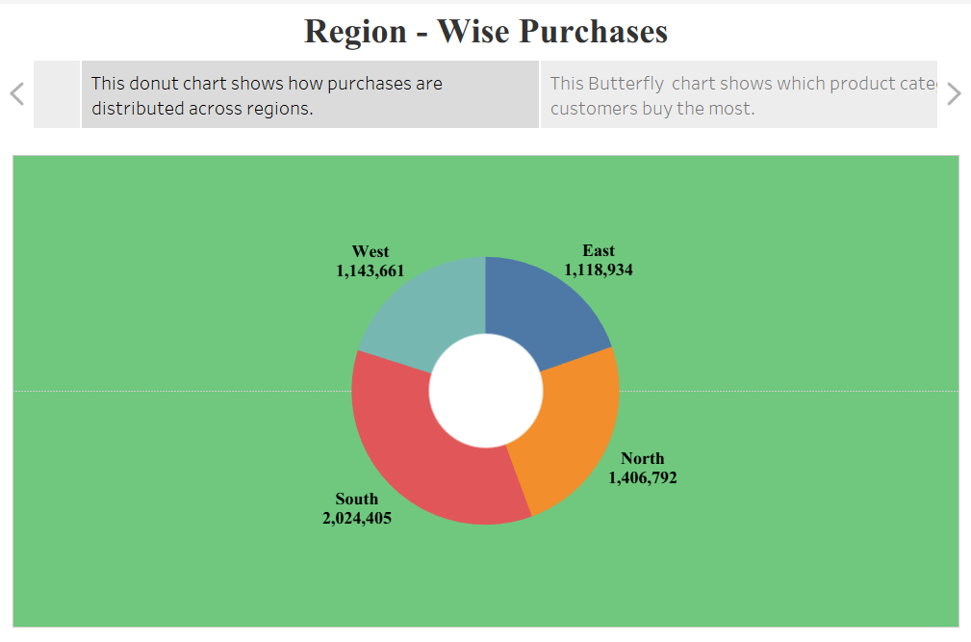

Milestone 6: Performance Testing

Activity 1: Amount of Data Rendered to DB

- The amount of data that is rendered to a database depends on the size of the dataset and the capacity of the database to store and retrieve data.

- Open the MySQL Workbench, go to the database then click to expand the tables,select the table and click on (i) button to get the information related to table such as column count,table rows etc.
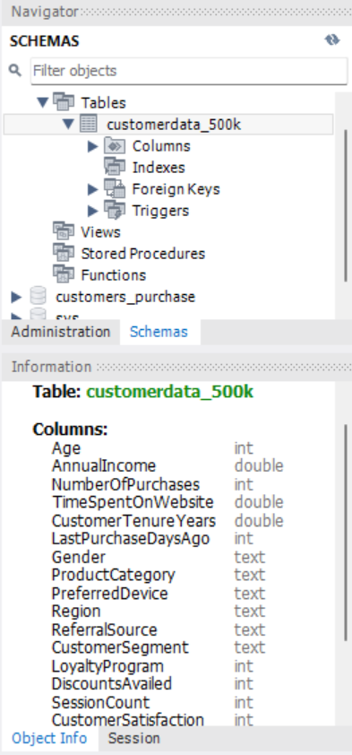
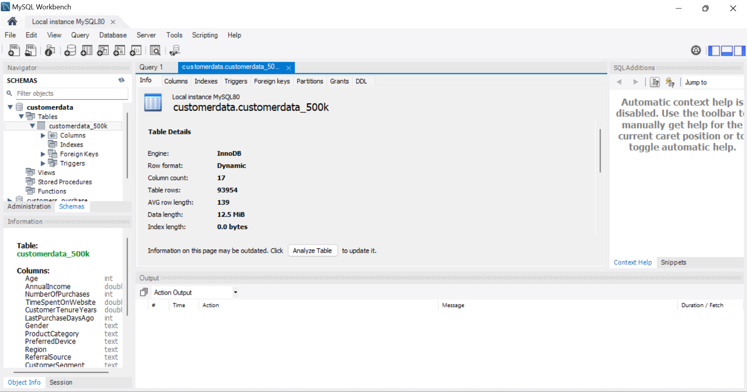

Activity 2: Utilization of Data Filters

Activity 3: No of Calculation Fields
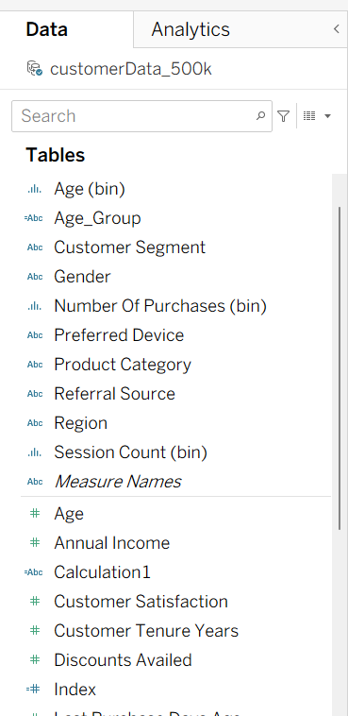
Activity 4: No of Visualizations/ Graphs

- Total Customers
- Average annual Income
- Total Purchase
- Avg Customer Satisfaction
- Trend by Age Group
- Region - wise Purchase
- Number of Purchase Per Product Category
- Number of Purchase by Age
- Distribution of Purchase by Age
- Discounts Availed vs Number of Purchases

Milestone 7: Web integration
Publishing helps us to track and monitor key performance metrics, to communicate results and progress. help a publisher stay informed, make better decisions, and communicate their performance to others.
Publishing dashboard and reports to tableau public
Step 1: Go to Dashboard/story, click on share button on the top ribbon
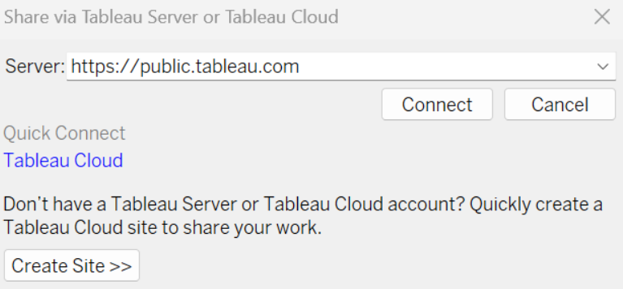
Give the server address of your tableau public account and click on connect.
Explanation Video: - Tableau dashboard, story Publish.mp4

Step 2: Once you click on connect it will ask you for tableau public user name and password
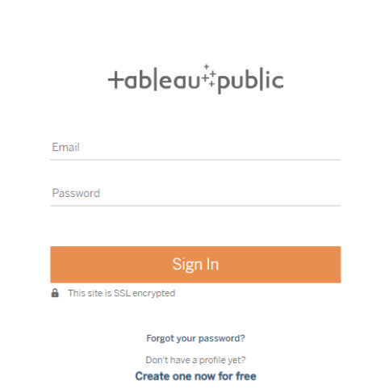
Once you login into your tableau public using the credentials, the particular visualization will be published into tableau public
Note: While publishing the visualization to the public, the respective sheet will get published when you click on share option.

Activity 1: Dashboard and Story embed with UI With Flask

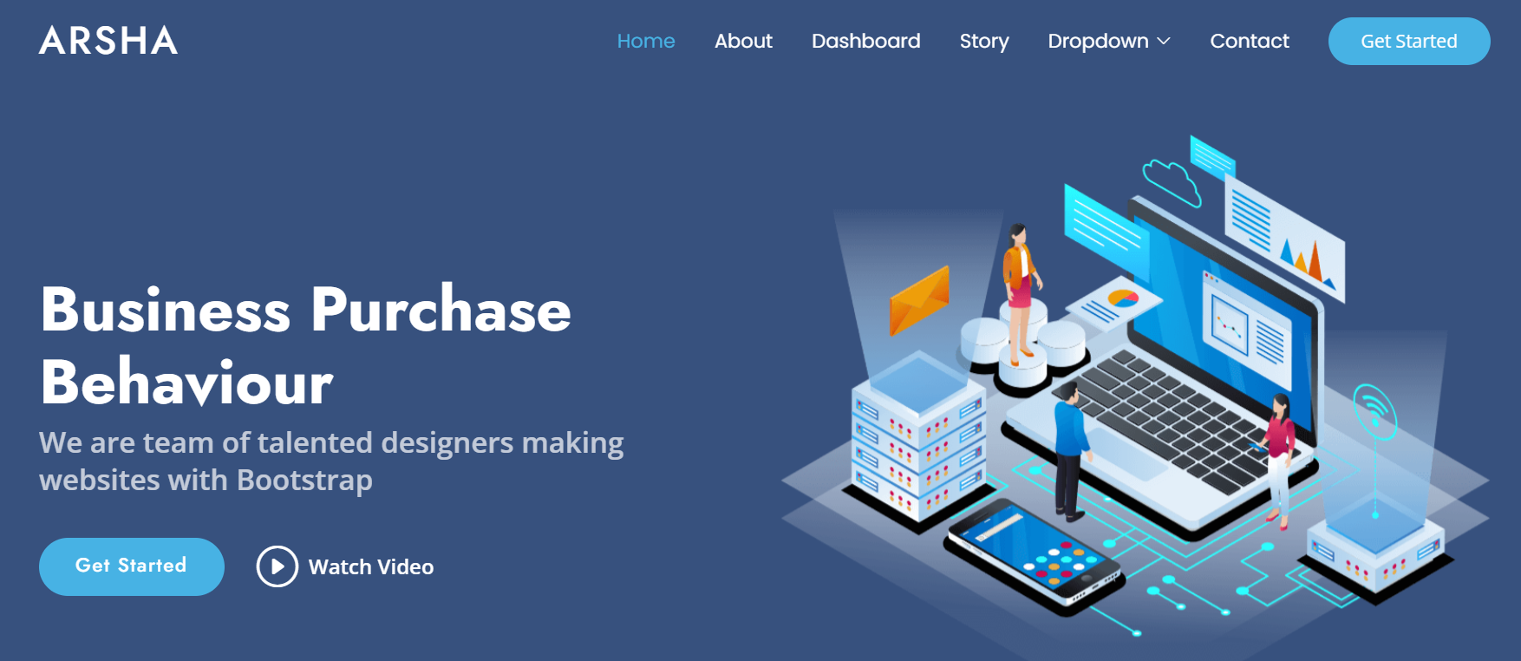
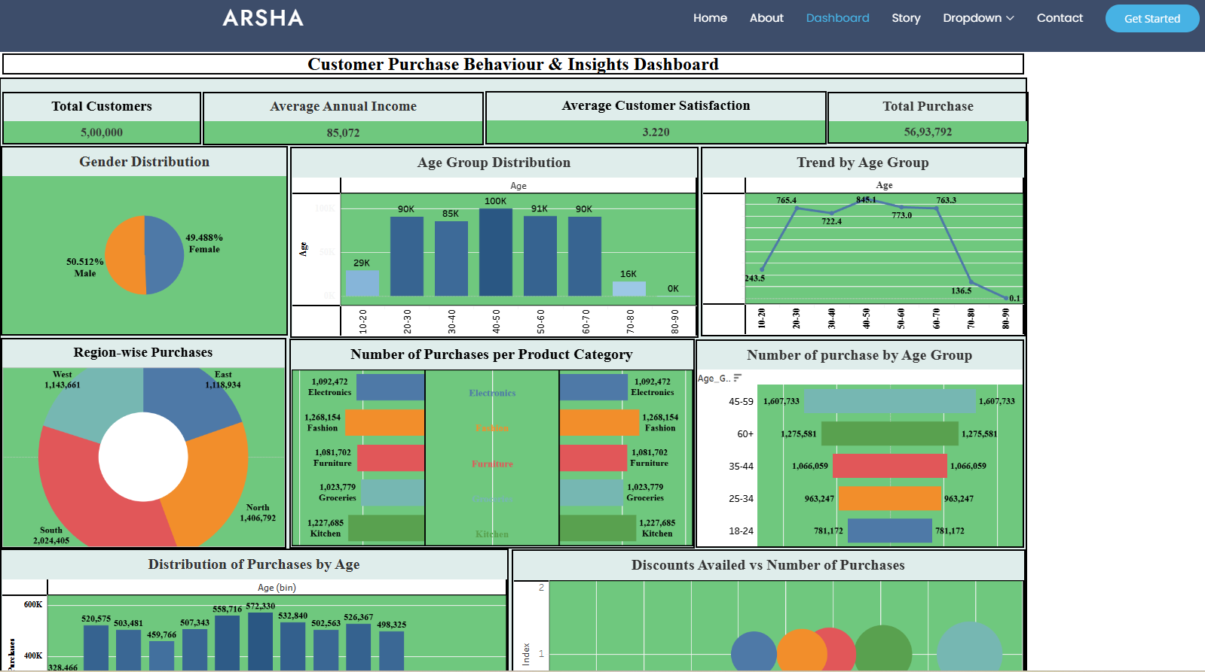
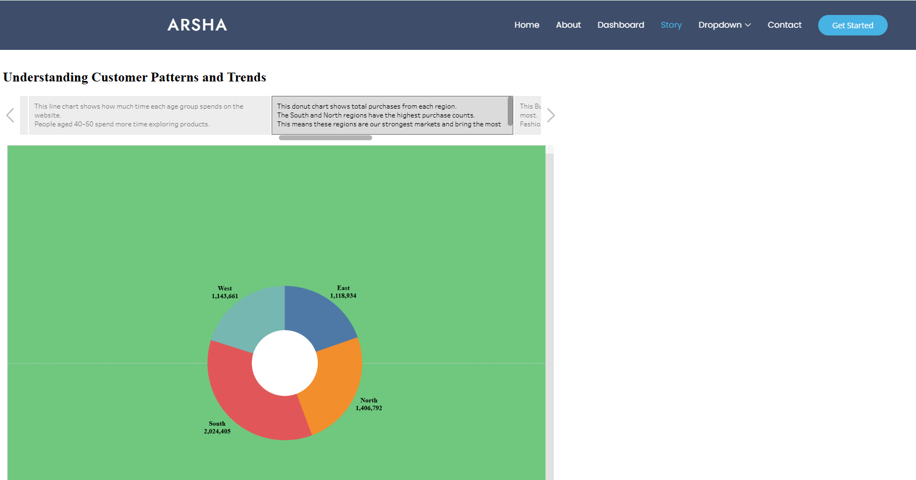

Milestone 8: Project Demonstration & Documentation
Below mentioned deliverables to be submitted along with other deliverables
Activity 1: - Record explanation Video for project end to end solution
Activity 2: - Project Documentation-Step by step project development procedure
Create document as per the template provided

